Task #1

x=rbinom(50,1,.2)

> x

[1] 0 0 1 0 0 0 0 0 0 0 0 0 0 0 0 0 0 0 0 0 0 0 0 0 0 0 0 0 1 1 0 0 0

[34] 1 0 0 1 0 0 0 0 0 0 0 0 1 0 0 1 1

> thetaobs=sum(x)/50

> thetaobs

[1] 0.2

Yes, because it was reasonably close to 𝞡0 (2 standard deviations)

Task #2

A)

Comparing .4 to the sample proportion of .2, I would not accept the guess because it is farther than 2 standard deviations away (.2614,.5386)

B)

a)

> N<-10000; n<-50; theta<-.4

> MySamples<-replicate(N, rbinom(n,1,theta))

b)

> thetak=colSums(MySamples)/50

c)

> hist(thetak, right = FALSE, xlim = c(0,1), xlab = "Sample proportion")

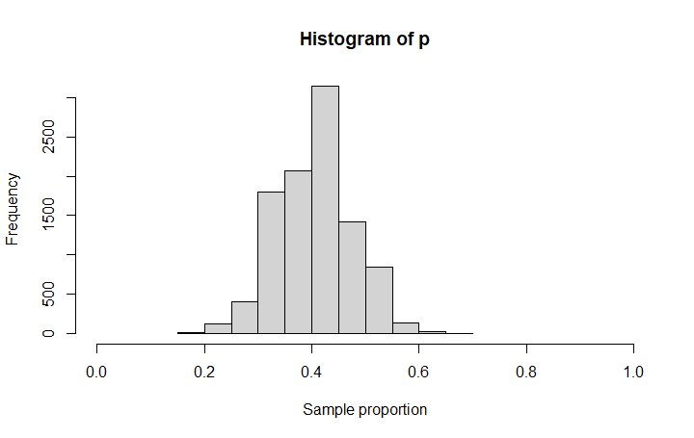

d)

> mean(thetak<thetaobs)

[1] 0.0011